TMT/Varanasi /S0653/2026 19.01.2026

To,
Niraj Kumar,
Mobile : 8299840579,
Varanasi.

Dear sir,

Sub: - Supply of Roll Forming Machine - With C section Roll Forming.

Thank you very much for your enquiry regarding your requirement of roll forming machine mainly for C Section. We are glad to inform you that we would be in a position to supply you the required equipment. Given below are the required specifications and description of the machine and our terms and conditions.
Prices
The cost of Roll forming machine with C section tooling along with de coiler, Entry guide, punching press and tooling, main roll forming machine, side guides, delivery run out table along with drive system and entry shear also with sheet leveler cum feeder Rs 36,00,000/- (Rupees Thirty-Six Lakhs only)

LIST OT EQUIPMENT
- MANUAL DE COILER 8 MT CAPACITY
- SHEET LEVELER CUM SERVO FEEDER 3 HP SERVO
- PUNCHING PRESS WITH 3 PUNCHING STATIONS
- ROLL FORMING MACHINE WITH 14 PASSES
- EN 31 C PROFILE TOOLING
- 20 HP DRIVE WITH 2 NUMBER RUDUCTION GEAR BOXE.
- COMPLETE ELECTRICALS ALONG WITH AUTOMATION – PLC
- DELIVERY SHEAR WITH 7.5 HP POWERPACK

TECHNICAL SPECIFICATION:

Productivity : ROLL FORMING CUT TO SIZE PROFILE

Manpower required : ONE OPERATOR ONE ASST. REQUIRED

Total Power Required : 27.5 HP

Set up time : COIL LOADING 8-10 MIN, SHEET FEEDING 3-4 MIN

Production capacity : 6000 KG PER SHIFT 8 HOURS

Working hours per day : 24 hours

Line direction : LEFT TO RIGHT

Overall floor space required : 21 METERS (L) 2 METERS (W) 2 METERS (H)

Approx weight : 8000 KG

Line speed : 3-15 MPM

Model No : TM/RF/113

Model Type : CRFM

MATERIAL SPECIFICATIONS
Type of material to be processed : CR/MS/HR

uts : 32-42 KG/MM2
% Elongation : 18-25
Shear strength : 40-45 KG/MM2

Maximum width can be processed : 350 MM

Minimum width can be processed : 75 MM

Maximum thickness can be processed : 4.0 MM

Minimum thickness can be processed : 0.8 MM

ENTRY COIL SPECIFICATIONS
Maximum weight of coil : 5 TON

Maximum od of coil at entry : 1600 MM

Minimum od of coil at entry : 600 MM

DE COILER SPECIFICATIONS
Model : SINGLE ARM

Load - capacity : 8000 KG MAX.

width : 650MM

Mandrel movement : DIA 450 MM - 550 MM

Mandrel Height from ground : 1100 MM

Mandrel expansion : MANUAL

Construction : M. S. FABRICATED.

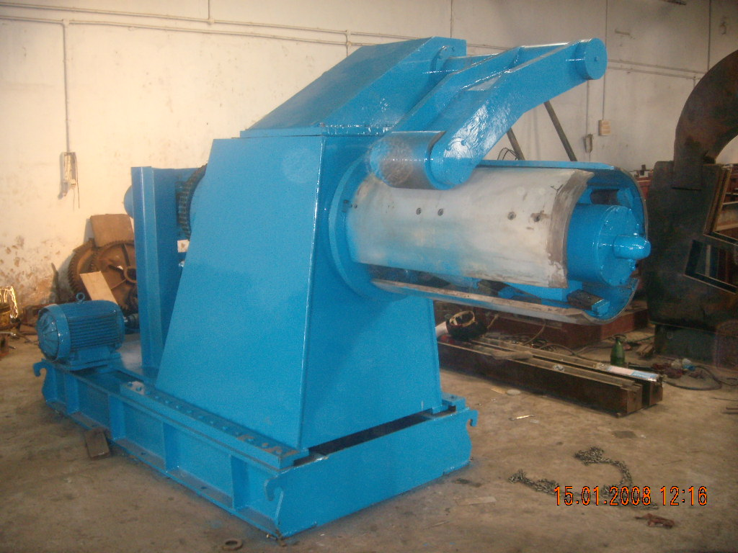

MILL SPECIFICATIONS

Roll shaft diameter : DIA 60 MM

The vertical distance between shafts : 330 MM

The horizontal distance between shafts : 450 MM

Number of forming stations : 14 NOS

Drive (AC) : 20 HP

Punching and entry shear : 7.5 HP {power pack)

Speed of the machine : 0-15 meters/max

Shaft material : EN19

Rollers Material : EN31

Hydraulic tank capacity : 200 liters

Description of the equipment

Roll Forming Machine

Main Base
The main base is MS fabricated structure and adequately ribbed to minimize the distortion. It is accurately machined on top and bottom surfaces the threaded holes are made on the bed for positioning the stands.

Entry Guide
The entry side of the machine will be equipped with guide table and the guide wheels bar which will be responsible for centering the leading ends of the strip into the first pass.

Mill stands
The stands are mounted on the bed of the machine the line alignment can be easily done due to guide ways arranged on the bed of the machine. Each forming head consists of a fixed housing and sliding type out board housing. The mill stands will be arranged to locate shafts mounted on anti-friction bearings. For the top shafts the bearings are housed in the cartridge type bearing blocks. The bottom shaft bearings are located in the bored machined in the housings. The bottom arbors are fixed in position whereas the top arbors along with cartridge blocks could be raised or lowered in vertical guides machined in housings.

Roll shafts
The roll shafts will be manufactured from quality steel and will be keyed to locate tooling.

Drive
The drive to the roll former will be by means of a gear box system. The main drive will be provided by means of 20 HP motor. The speed of the roll former is fixed.

Delivery runout table
The delivery runout table is with four meters length.

Cutoff unit
The cutoff unit with hydraulic press along with cutting die set will be placed in the machine delivery side.

GENERAL TERMS & CONDITIONS:

- Price quoted per unit ex-work. Hyderabad.
- Following charges are additional to your account.
- Freight Charge : As actual to be borne by you.
- Sales Tax : 18% Extra as applicable
- Packing charge : As actual to be borne by you.
- Insurance : As actual to be borne by you.
- Payment : 50% advance along with order,
: balance 50% after installation and before delivery
- Delivery : within 8 weeks from date of advance received
- Validity : One month from the date of submission.
- Inspection : Inspection at our works prior to dispatch.
- Warranty : The machine is warranted for a period of 12 months from the date of dispatch against any manufacturing defects/ faulty material or bad workmanship of any part or component but not against any kind of abnormal or improper use of machine. Defective part or component will be replaced or repaired free of cost. Electrical components are outside the scope of this warranty.
- Commissioning : Erection & commissioning done by you, but required technical support & guidance provide by us at additional cost.

NOTE:
- Oil is not in scope of our supply.
- Raw material for trial is to be arranged by you at your cost.

We are sure you will find our offer in line with your requirements. Should you require any further clarification please contact T. Sivaramakrishna 9246221106. Email: techno9246221106@gmail.com WhatsApp No: 9849207176

Thanking you and assuring you of our best services.

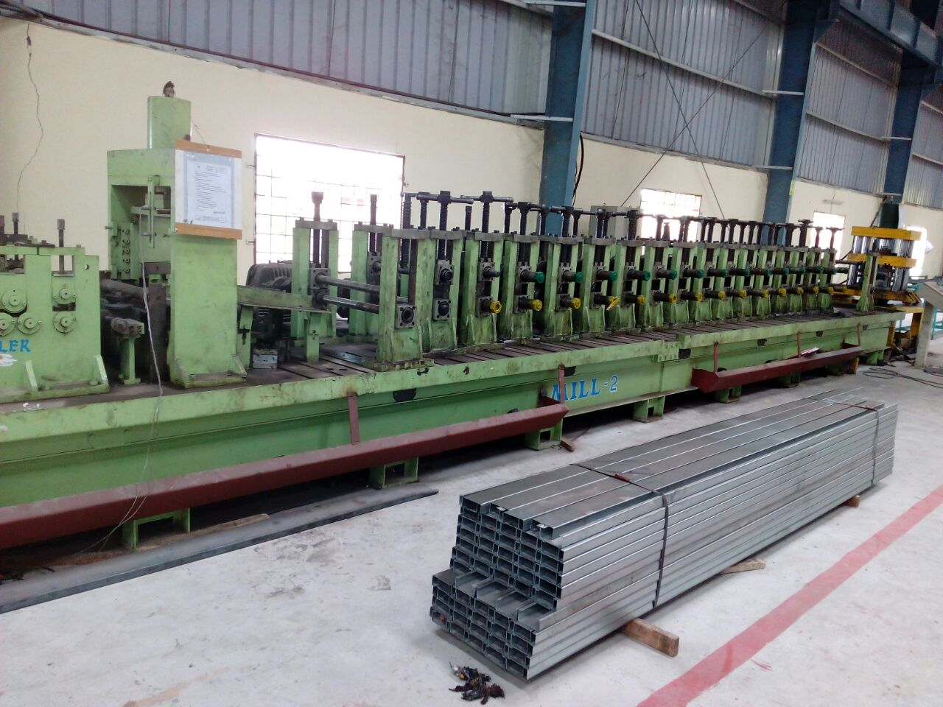

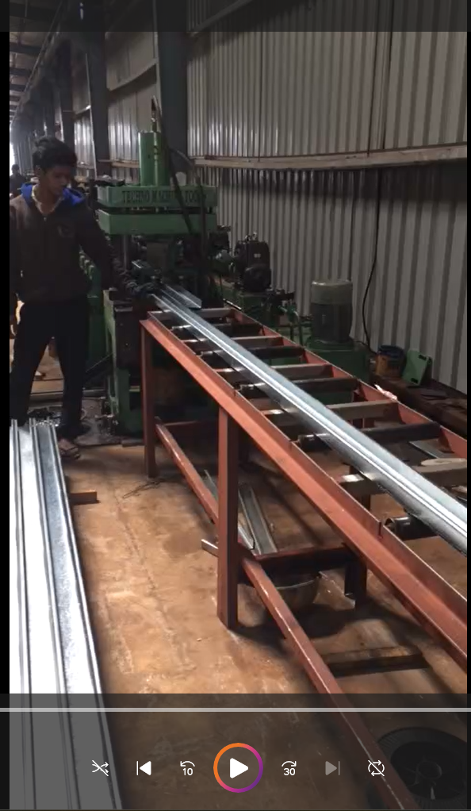

For TECHNO MACHINE TOOLS

(T. SIVARAMAKRISHNA)

